**EYECHECKUP MANAGEMENT SYSTEM MANUAL**

Step One

Download the zip file.

Unzip the file, it’s called EyeCheckUpSystem files

Step Two

Open the file and right the file written as EyeCheckupSystem.sln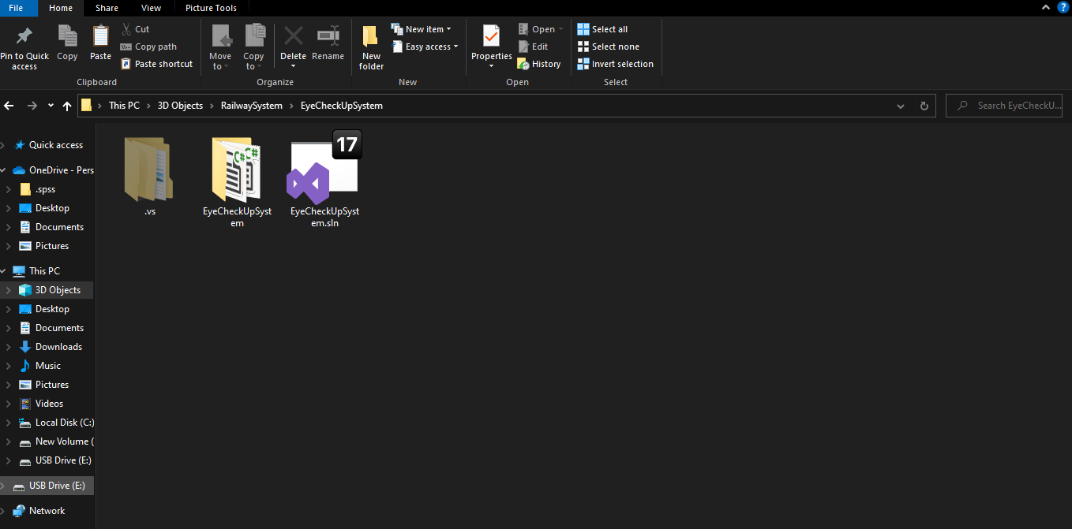

Load the database file into the system.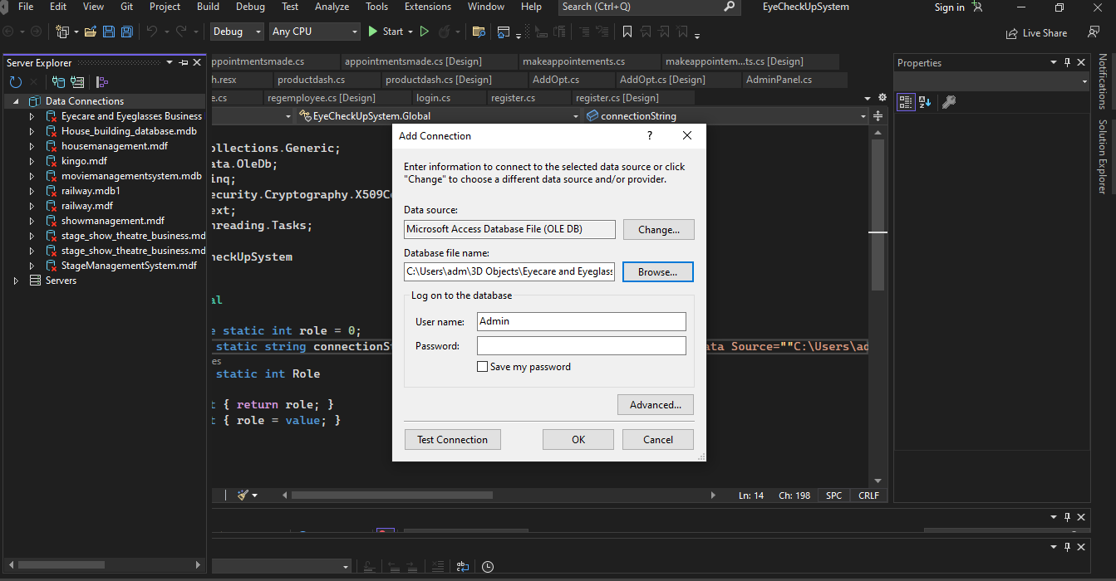

Right click on the database file once it has loaded and the connection is successful, to get the connection string.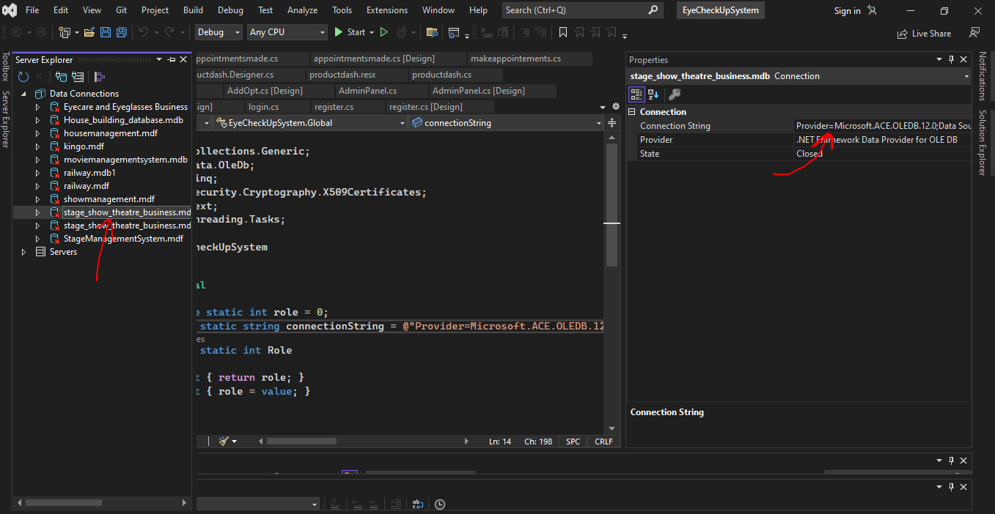

Copy the connection string and use it the global.cs class, this enables the application to connect to the whole forms in the application.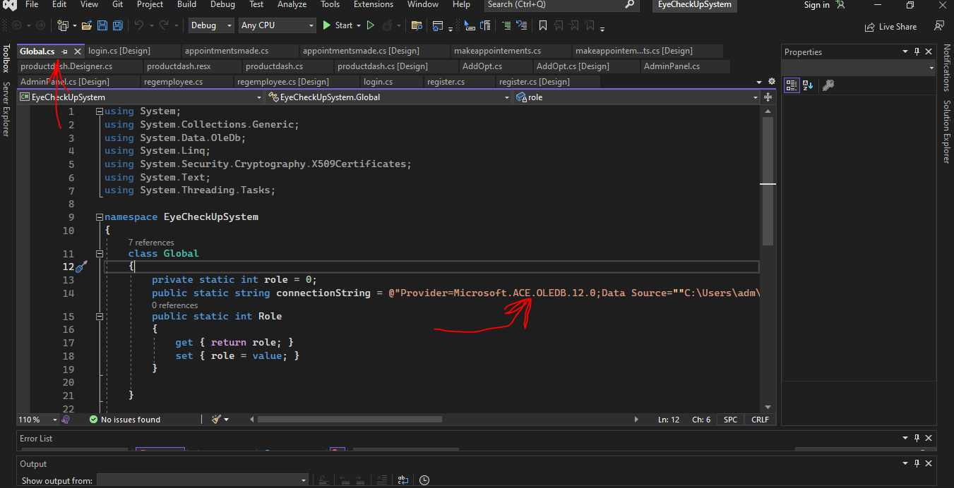

Login in the application

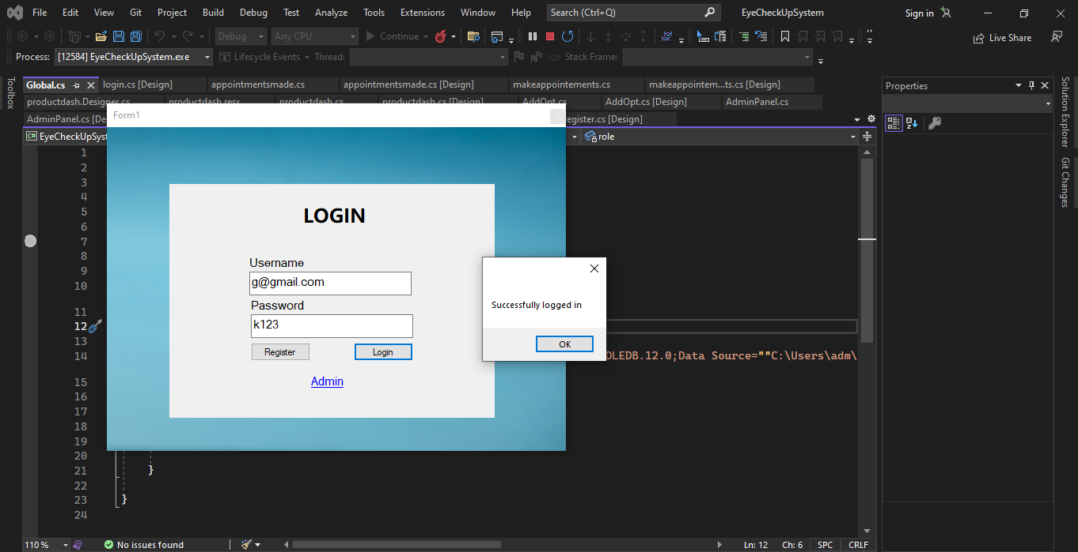

You can now do the appointments and buy eyewear.